Packet Tracer – Design and Implement a VLSM Addressing Scheme
Student Note: Type your answers in BLUE font.

Addressing Table
Device | Interface | IP Address | Subnet Mask | Default Gateway
[[R1Name]] | G0/0 |  |  | N/A
Police | G0/1 |  |  | N/A
[[R1Name]] | S0/0/0 |  |  | N/A
[[R2Name]] | G0/0 |  |  | N/A
Schools | G0/1 |  |  | N/A
[[R2Name]] | S0/0/0 |  |  | N/A
PD-1 | VLAN 1
PD-2 | VLAN 1
PS-101 | VLAN 1
PS-115 | VLAN 1
PD-1-11 | NIC
PD-2-23 | NIC
PS-101-87 | NIC
PS-101-12 | NIC

Objectives
In this lab you will design a VLSM addressing scheme given a network address and host requirements. You will configure addressing on routers, switches, and network hosts.
- Design a VLSM IP addressing scheme given requirements.
- Configure addressing on network devices and hosts.
- Verify IP connectivity.
- Troubleshoot connectivity issues as required.

Background / Scenario
You have been asked to design, implement, and test an addressing scheme for a customer. The customer has given you the network address that is suitable for the network, the topology, and the host requirements. You will implement and test your design.

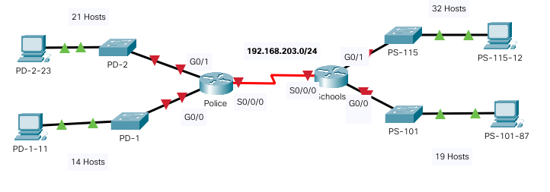
Instructions
You have been given the network address192.168.203.0/24 by your customer. The host address requirements are:

Requirements
Host Requirements:
LAN | Number of Addresses Required
PS-115 LAN | 32
PD-2 LAN | 21
PS-101 LAN | 19
PD1-1 LAN | 14
Design Requirements
- Create the addressing design. Assign the largest subnet first, in descending order.
- Provide the most efficient subnet possible for the point-to-point link between the routers.
- Assign the subnet addresses using the following table, starting with the largest subnet.
Subnet Description | Number of Hosts Needed | Number of usable hosts per subnet | IP subnet  (Network address)/prefix | First Usable Host Address | Last Usable Host Address | Broadcast  Address
PS-115 LAN | 32
PD-2 LAN | 21
PS-101 LAN | 19
PD1-1 LAN | 14
WAN | 2
Configuration Requirements
Note: You will configure addressing on all devices and hosts in the network.
Complete the Addressing Table on the first page as follows, and then configure the devices in the Packet Tracer activity.

You should connect a console cable between PD-2-23 to the Police, etc.
- Assign the first usable IP addresses in the appropriate subnets to Police for the two LAN links and the WAN link.
- Assign the first usable IP addresses in the appropriate subnets to Schools for the two LANs links. Assign the last usable IP address for the WAN link.
- Assign the second usable IP addresses in the appropriate subnets to the switches.
- The switch management interface should be reachable from hosts on all of the LANs.
Assign ip address to VLAN 1, and configure default route (gateway): HINT:
switch(config)# int vlan1
switch(config-if)# ip address A.B.C.D X.X.X.X
switch(config-if)# no shut
switch(config-if)# ip default-gateway A.B.C.D

- Assign the last usable IP addresses in the appropriate subnets to the hosts.

Verify connectivity:
If the addressing design and implementation are correct, all hosts and devices should be reachable over the network. Test using ping from one PC to another.

